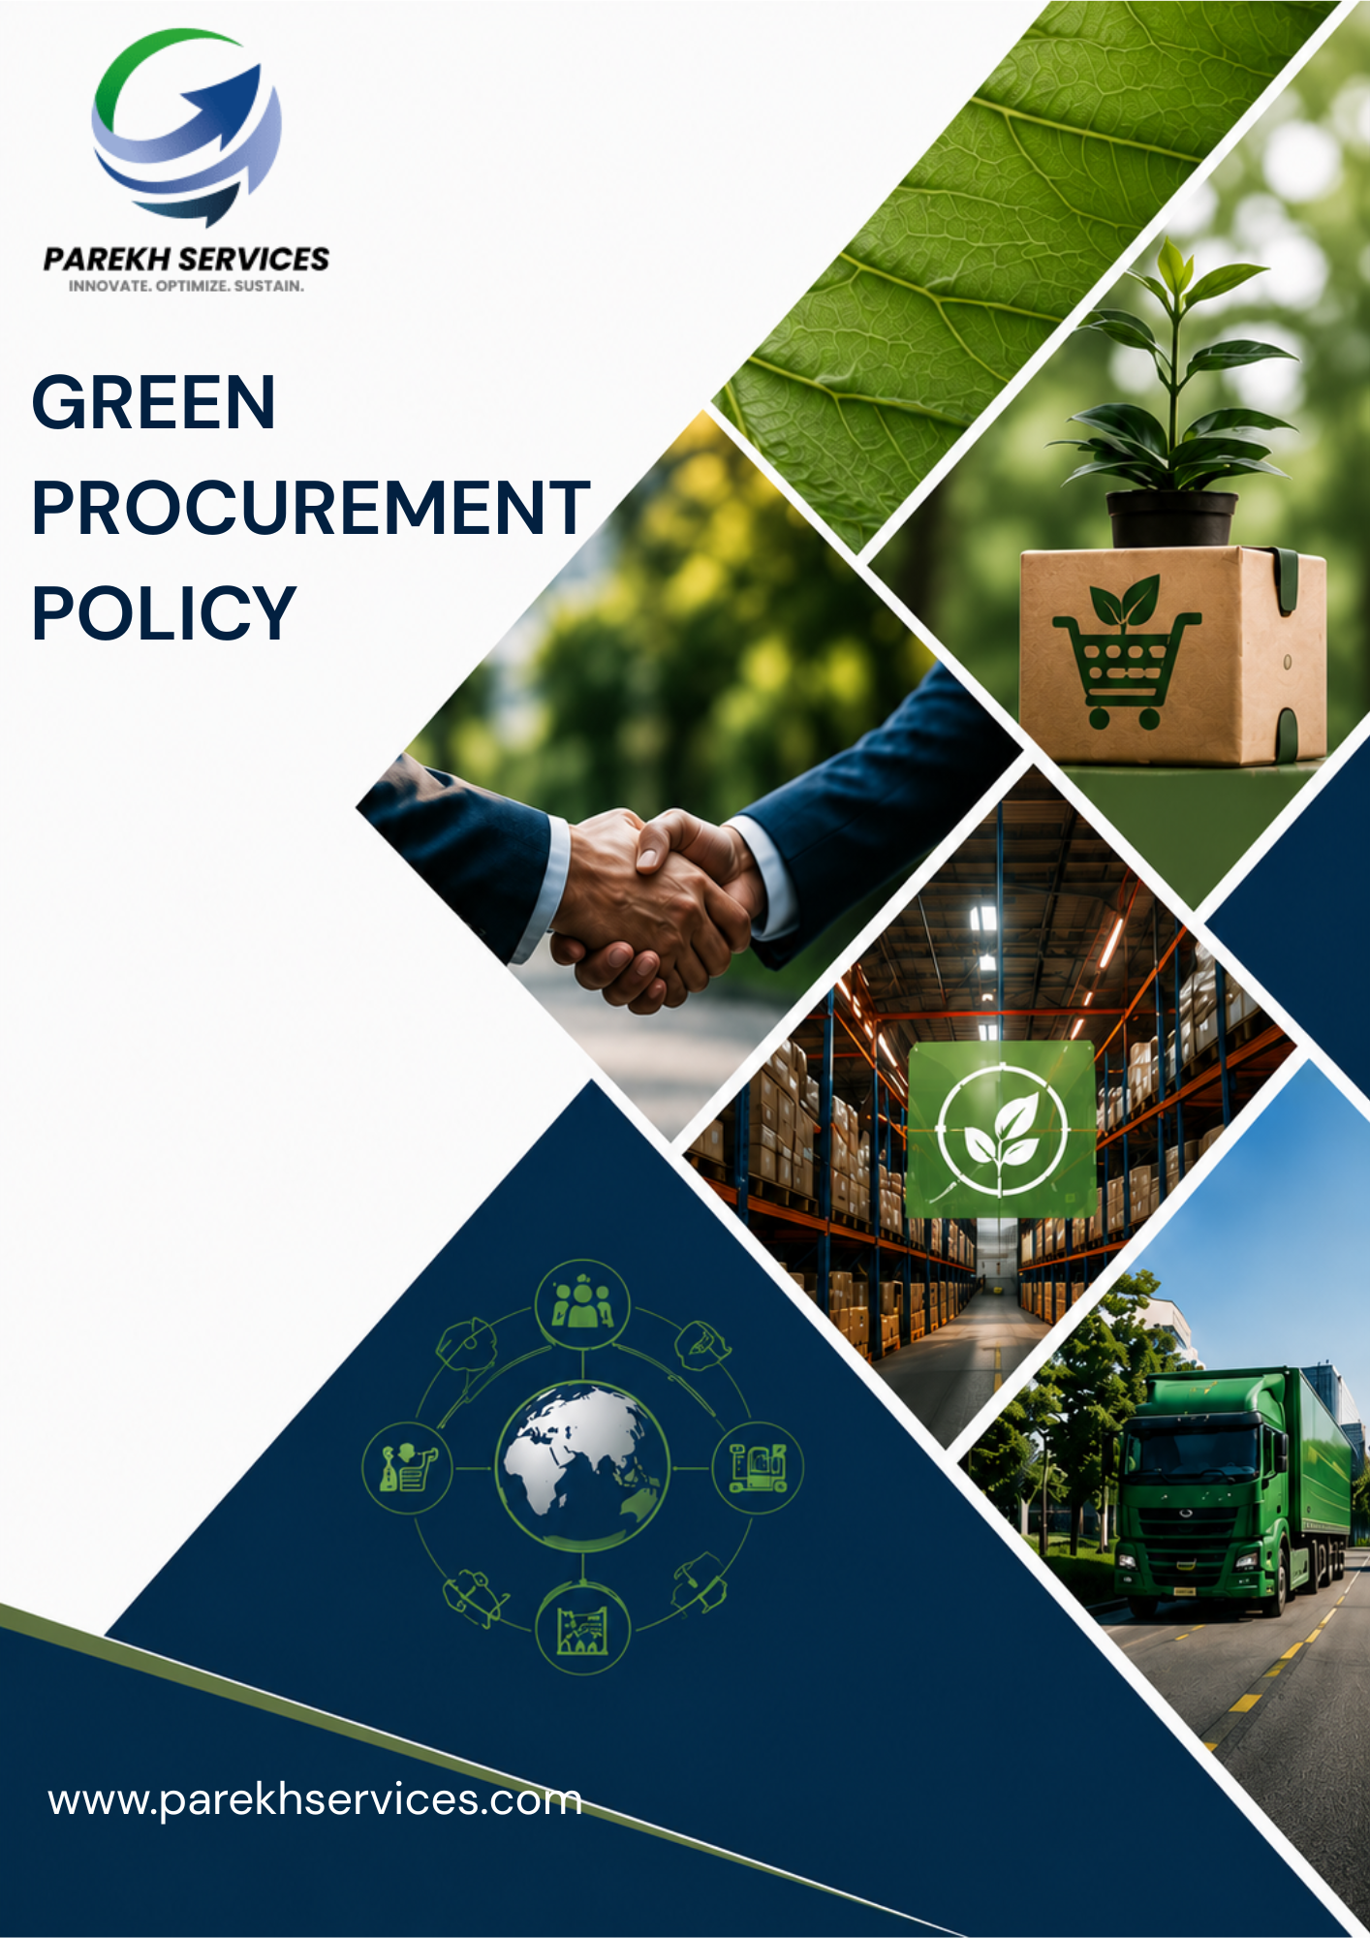
Contents

Introduction 3
Scope 3
Purpose 4
Key Focus Areas 4
Policy Commitments 4
Targets 6
SDGs Covered 8
Roles & Responsibilities 8
Reporting 10
Continuous Improvement 10
Review Mechanism 10
Acknowledgement 11

Introduction
Parekh E-Com and Warehousing Services Private Limited (PEWSPL) is committed to conducting procurement activities in a responsible, ethical, transparent, and sustainable manner. As a technology-driven logistics and supply chain solutions provider, PEWSPL integrates environmental, social, governance (ESG), quality, safety, and compliance considerations into its procurement and supplier management practices to support sustainable business growth and long-term stakeholder value.

Scope
This policy applies to all operations of PEWSPL, including transportation activities, operational facilities, warehouses, and office locations across all locations where PEWSPL operates. It covers all permanent, temporary, and contractual employees across all functions, as well as all internal and external stakeholders associated with PEWSPL, whether directly or indirectly engaged with the organization’s operations and services.
Sr. No. | Name of Operational Unit | (Corporate / Warehouse) | Registered Address of the Unit
1 | HO | Corporate | Parekh Ecom & Warehousing Services Pvt. Ltd., C/o Parekh Prints, 1st Floor, Italian Textile Compound, ITT Bhatti, Off Goregaon Mulund Link Road, Goregaon (E), Mumbai - 400 063
2 | Shakambari | Warehouse | Shakambari Logistic Park-Unit #A-1Premises # 1 to 7  Next to All Saint High School,  Pise Pipeline Road, Village Lonad  Tal-Bhiwandi - Thane, Maharashtra – 421302
3 | Lonikand | Warehouse | Parekh E-com & warehousing services Pvt. Ltd.  Chondhe Warehouse, Vadhu Khurd, Gate no-128/142/144,  Lonikand, Tal-Haveli, Dist-Pune Pin code- 412216, Maharashtra, India.
4 | Chakan | Warehouse | Gut No. 318/02, (P), Village-Kuruli, Tal. Khed, Dist.-Pune, 410501

Purpose
The purpose of this Policy is to:
- Promote responsible and sustainable procurement practices across PEWSPL operations.
- Encourage suppliers and business partners to adopt environmentally and socially responsible practices.
- Reduce environmental and social risks within the supply chain.
- Ensure compliance with applicable laws, regulations, and ethical standards.
- Support resource efficiency, operational resilience, and long-term sustainable growth.
- Strengthen transparency, accountability, and supplier engagement throughout the procurement lifecycle.

Key Focus Areas
PEWSPL shall focus on the following key human rights and labour management areas:
- Environmental Responsibility: Promoting environmentally responsible procurement through energy-efficient products, sustainable packaging, waste reduction, and low-emission logistics solutions.
- Ethical Business Practices: Ensuring fair, transparent, and ethical procurement practices while preventing corruption, fraud, and conflicts of interest.
- Social Responsibility: Encouraging suppliers to uphold fair labor practices, workplace safety, human rights, diversity, and employee well-being.
- Compliance & Governance: Ensuring compliance with applicable legal, environmental, health & safety, and corporate governance requirements across the supply chain.
- Sustainable Innovation: Promoting innovative, technology-driven, and resource-efficient solutions that support sustainable and paperless procurement practices.

Policy Commitments
- General Commitments
- We will integrate sustainability considerations into procurement and supplier selection processes through ESG-based evaluation criteria.
- We strive to encourage suppliers to adopt management systems and compliance practices aligned with standards such as ISO 9001, ISO 14001, and ISO 45001 wherever applicable.
- We aim to maintain periodic supplier assessments and on-site audits to evaluate compliance with PEWSPL’s sustainability, quality, and operational requirements.
- We strive to promote ethical, transparent, and fair procurement practices by strengthening governance and monitoring mechanisms.
- We aim to encourage suppliers and service providers to align with PEWSPL’s sustainability values and ESG expectations through continuous engagement.
- We are committed to supporting responsible sourcing practices that minimize environmental and social risks across the supply chain.
- We will strengthen supplier engagement and sustainability awareness through periodic communication, collaboration, and training initiatives.
- We aim to maintain the implementation and communication of the Supplier Code of Conduct covering ethics, compliance, human rights, environmental responsibility, and occupational health & safety.
- Social Compliance in Supply Chain
- We will encourage suppliers to uphold human rights, fair labor practices, and equal opportunity principles through responsible employment practices.
- We strive to promote safe, healthy, and secure working conditions across the supply chain through compliance-driven operational controls.
- We are committed to discouraging child labor, forced labor, harassment, discrimination, and unethical employment practices through supplier compliance expectations.
- We aim to encourage suppliers to strengthen occupational health and safety practices aligned with ISO 45001 principles to support safe and healthy workplaces.
- We aim to encourage suppliers to support employee welfare, training, and skill development initiatives to strengthen workforce capability.
- We seek to foster diversity, inclusion, and responsible workplace practices among suppliers and contractors through fair engagement principles.
- We will provide training to our Purchasing Department on Human rights issues that may arise from improper procurement decisions.
- We are committed to identifying and minimizing social risks within our supply chain by promoting ethical labor practices, human rights, and responsible working conditions among suppliers
- Supplier Performance & Quality Management
- We will procure goods and services that meet required quality, safety, and operational standards through structured procurement specifications.
- We strive to encourage suppliers to maintain quality management systems and operational controls aligned with ISO 9001 principles for continuous improvement and service reliability.
- We are committed to promoting continuous improvement and supplier performance enhancement through periodic evaluations and feedback processes.
- We seek to encourage suppliers to adopt process optimization and operational best practices to improve efficiency and service quality.
- We will support proactive communication and coordination with suppliers to improve supply chain responsiveness and operational continuity.
- Environmental Stewardship by Suppliers
- We aim to encourage suppliers to reduce energy consumption, greenhouse gas emissions, and environmental impacts through resource-efficient operational practices.
- We aim to support environmentally responsible procurement by favouring suppliers, products, and services with lower environmental impact where cost and quality considerations are comparable.
- We seek to encourage suppliers to implement environmental management practices aligned with ISO 14001 principles for improved environmental performance and compliance management.
- We strive to support responsible waste management and pollution prevention practices through supplier awareness and sustainability initiatives.
- We are committed to encouraging suppliers to implement environmental management systems and sustainability-focused operational practices.
- We will promote digital and paperless procurement practices through technology-enabled procurement systems and electronic documentation.
- We will provide training to our Purchasing Department on environmental issues that may arise from improper procurement decisions.
- We are committed to reducing environmental risks across our supply chain by encouraging suppliers to adopt environmentally responsible and sustainable operational practices.
- Local Sourcing & Supplier Development
- We aim to encourage procurement from local and regional suppliers wherever feasible to support local economic development and supply chain resilience.
- We will support supplier capability development and long-term business partnerships through collaboration and engagement initiatives.
- We strive to promote inclusive and responsible supplier engagement practices through fair and transparent procurement processes.
- We are committed to strengthening collaboration and communication with suppliers to improve operational efficiency and supply chain resilience.

Targets
- General Commitments
- We aim to increase sustainable supplier assessment coverage by 30% by FY 2029–30 from the FY 2022–23 baseline.
- We strive to conduct at least 2 supplier sustainability engagement or awareness programs annually from the FY 2022–23 baseline through FY 2029–30.
- We strive to integrate ESG-related evaluation criteria into 100% of key supplier assessment processes by FY 2029–30 from the FY 2022–23 baseline.
- We aim to increase engagement with suppliers maintaining ISO-certified management systems by 20% by FY 2029–30 from the FY 2022–23 baseline wherever feasible.
- We strive to increase supplier participation in sustainability-related disclosures and information sharing by 25% by FY 2029–30 from the FY 2022–23 baseline.
- We aim to conduct sustainability screening for at least 80% of new key suppliers by FY 2029–30 from the FY 2022–23 baseline.
- Social Compliance in Supply Chain
- We aim to increase supplier awareness initiatives related to workplace safety, labor rights, and ethical employment practices by conducting at least 2 engagement programs annually from the FY 2022–23 baseline through FY 2029–30.
- We aim to integrate social compliance considerations into 100% of major supplier evaluation processes by FY 2029–30 from the FY 2022–23 baseline.
- We strive to encourage 100% compliance with applicable labor and employment regulations among key suppliers by FY 2029–30 from the FY 2022–23 baseline.
- We aim to provide responsible sourcing, labor practices, and social compliance awareness training to at least 80% of relevant procurement employees by FY 2029–30 from the FY 2022–23 baseline.
- We aim to increase engagement with suppliers promoting employee welfare and skill development practices by 15% by FY 2029–30 from the FY 2022–23 baseline.

- Supplier Performance & Quality Management
- We aim to increase supplier performance evaluations covering quality and delivery parameters by 25% by FY 2029–30 from the FY 2022–23 baseline.
- We aim to increase procurement from suppliers maintaining documented quality management systems aligned with ISO 9001 principles by 20% by FY 2029–30 from the FY 2022–23 baseline.
- We strive to increase procurement from suppliers maintaining documented quality management practices by 20% by FY 2029–30 from the FY 2022–23 baseline.
- Environmental Stewardship by Suppliers
- We aim to increase procurement from suppliers implementing environmentally responsible practices such as energy efficiency, waste reduction, resource conservation, and environmental management initiatives by 25% by FY 2029–30 from the FY 2022–23 baseline.
- We aim to increase procurement of energy-efficient equipment and operational solutions by 20% by FY 2029–30 from the FY 2022–23 baseline.
- We aim to reduce procurement-related paper usage by 50% by FY 2029–30 from the FY 2022–23 baseline through digital procurement systems and paperless documentation.
- We strive to increase engagement with transportation partners adopting lower-emission logistics solutions, including EV and CNG-based vehicles, by 15% by FY 2029–30 from the FY 2022–23 baseline wherever operationally feasible.
- We aim to conduct at least 2 supplier environmental sustainability awareness or engagement initiatives annually from the FY 2022–23 baseline through FY 2029–30.
- We aim to provide responsible sourcing, environmental mangement awareness training to at least 80% of relevant procurement employees by FY 2029–30 from the FY 2022–23 baseline.
- Local Sourcing & Supplier Development
- We aim to increase procurement engagement with local suppliers by 20% by FY 2029–30 from the FY 2022–23 baseline.
- We strive to conduct at least 1 supplier development or capability-building initiative annually through FY 2029–30 from the FY 2022–23 baseline.
- We strive to increase supplier participation in training, awareness, or development programs by 25% by FY 2029–30 from the FY 2022–23 baseline.

SDGs Covered
 | 

Roles & Responsibilities towards this policy
  - Top Management
- Provide strategic direction and support for sustainable procurement practices across the organization.
- Approve procurement objectives, sustainability initiatives, and related improvement programs.
- Ensure adequate resources are available for implementation of the Green Procurement Policy.
- Promote responsible sourcing, ethical procurement, and supplier sustainability practices.
  - Procurement Head
- Implement sustainable procurement practices in supplier selection, evaluation, and procurement activities.
- Encourage suppliers and vendors to comply with environmental, social, ethical, and regulatory requirements.
- Integrate sustainability considerations into procurement decisions wherever feasible.
- Maintain transparent, fair, and ethical procurement processes.
- Monitor supplier performance related to sustainability and compliance requirements.
- Promote responsible sourcing, waste reduction, and environmentally responsible purchasing practices.
- Review this policy regularly.
  - Compliance / Sustainability / EHS Team
- Support implementation and monitoring of sustainability-related procurement initiatives.
- Conduct supplier sustainability assessments, reviews, or awareness programs where applicable.
- Monitor compliance with applicable environmental, labour, ethical, and regulatory requirements related to procurement activities.
- Support corrective action and continuous improvement initiatives related to supplier sustainability performance.
  - Department Heads and Employees
- Follow approved procurement procedures and ethical purchasing practices.
- Support procurement of environmentally and socially responsible products and services wherever feasible.
- Avoid conflicts of interest and maintain transparency during procurement-related activities.
- Report unethical procurement practices, non-compliance concerns, or supplier-related risks through designated channels.
  - Suppliers, Vendors, and Contractors
- Comply with applicable laws, regulations, and Company sustainability requirements.
- Support ethical business conduct, fair labour practices, environmental protection, and safe working conditions.
- Provide accurate and transparent information related to products, services, and compliance obligations.
- Cooperate with PEWSPL in sustainability assessments, audits, or improvement initiatives where applicable.

Reporting
Implementation of this Green Procurement Policy shall be monitored through annual reviews, supplier evaluations, compliance assessments, and monitoring of sustainability-related procurement practices. Supplier performance, procurement-related concerns, and corrective actions shall be reviewed regularly.

Continuous Improvement
PEWSPL is committed to continually improving sustainable procurement practices through regular review of procurement processes, supplier engagement initiatives, compliance monitoring, awareness programs, and implementation of improvement actions. The Company will continue strengthening responsible sourcing and ethical procurement practices in line with sustainability commitments and business requirements.

Review Mechanism
This Sustainable Procurement Policy shall be reviewed annually by the Procurement Head, or whenever significant changes occur in procurement practices, regulatory requirements, supplier expectations, or sustainability priorities, to ensure its continued relevance, effectiveness, and alignment with the Company’s responsible sourcing commitments.

Effective Date: 01-04-2025
Last Review Date: 01-01-2026
Next Review Date: 01-01-2027
Rev.No: 1.0

Approved By:
Procurement Head (PEWSPL)

Acknowledgement of this policy
I, the undersigned, acknowledge that I have received, read, and understood the Green Procurement Policy of Parekh e-Com and Warehousing Services Private Limited.
I understand the Company’s commitment to responsible sourcing, ethical procurement practices, environmental sustainability, regulatory compliance, and fair business conduct.
I understand that:
- I am responsible for complying with the principles and requirements outlined in this Policy.
- I must follow fair, transparent, and ethical procurement practices in all business activities.
- I must avoid conflicts of interest, unethical conduct, or non-compliant procurement practices.
- I must support sustainable sourcing and responsible supplier engagement wherever feasible.
- I must promptly report procurement-related concerns, unethical practices, or compliance violations through designated channels.
By signing this acknowledgement, I confirm my commitment to supporting the Company’s sustainable procurement objectives and responsible business practices.

Employee Name: ___________________

Designation: ______________________

Department: ______________________

Date: ____________________________

Signature: ________________________

